# Exercises: jQuery, DOM and Events

Problems for exercises and homework for the [“JavaScript Advanced” course @ SoftUni](https://softuni.bg/courses/javascript-advanced). Submit your solutions in the SoftUni judge system at <https://judge.softuni.bg/Contests/278/jQuery-and-DOM>.

## Book Generator

Create a function that accepts a selector, a title, an author and an ISBN and **uses** them to **create** the **HTML code** for a **book** and **inserts it** into the **selector**.

### HTML and JavaScript Code

You are given the following **HTML** code:

|  |
| --- |
| book-generator.html |
| <!DOCTYPE **html**> <**html lang="en"**> <**head**>  <**meta charset="UTF-8"**>  <**title**>Book Generator</**title**>  <**script src="https://code.jquery.com/jquery-3.1.0.min.js"  integrity="sha256-cCueBR6CsyA4/9szpPfrX3s49M9vUU5BgtiJj06wt/s="  crossorigin="anonymous"**></**script**> </**head**> <**body**> <**div id="wrapper"**>  </**div**> <**script src="book-generator.js"**></**script**> <**script**>  window.onload = **function** () {  *createBook*(**"#wrapper"**, **"Alice in Wonderland"**, **"Lewis Carroll"**, 1111);  } </**script**> </**body**> </**html**> |

It comes together with the following **JavaScript** code:

|  |
| --- |
| book-generator.js |
| **function** *createBook*() {  *//* ***TODO*** } |

Your function will receive **4 parameters** - a **string value** representing a selector (for example "#wrapper" or ".root"), a **string value** representing the titleof the book, a **string value** representing the authorof the book and a **number** representing the ISBN of the book. **After** the book is **created** it should be **attached** to the passed in **selector**.

The **number** in the Id of the containing div should be **incremented** by **one** **for each successive book created** (i.e. first book should have id = "book1", second id = "book2" and so on…). The title, author and ISBN should be **paragraphs** with a class equal to their **respective role** - class="title" for the **title paragraph**, class="author" for the **author paragraph** and class="isbn" for the **ISBN paragraph**. A book should also contain **2 buttons** – [Select] and [Deselect], when the [Select] button is pressed the border of the div element should be set to "2px solid blue". When the [Deselect] button is pressed it should be set to "none".

### Screenshots

The HTML code for a book should have the following structure:

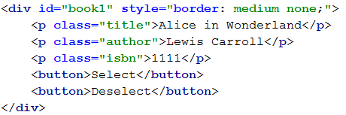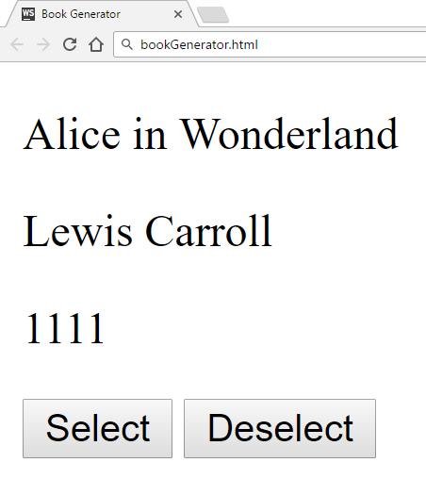

Selected book:

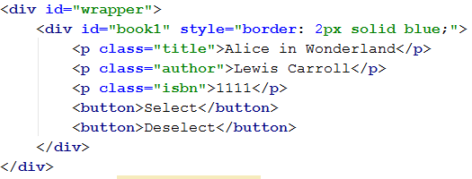

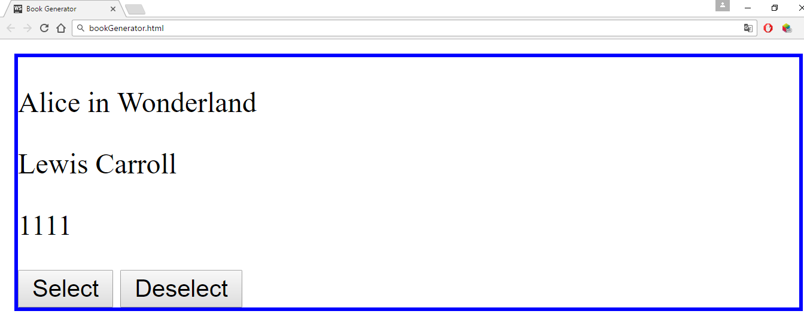

### Hints

You can use what is known as an **IIFE** (Immediately Invoked Function Expression) to declare and instantly execute a function that will keep the id variable in its scope. This way you will receive the inner function and for it the variable id will be **shared between all calls**, essentially becoming like a **static variable** for the function:

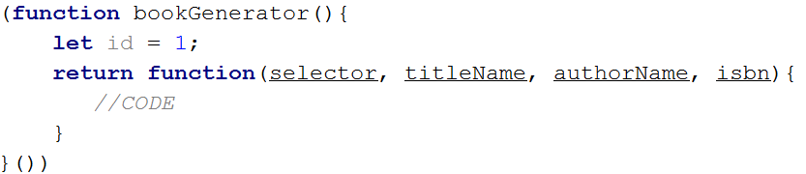

An **element’s** **css properties** can easily be changed with **jQuery** in the following way:



## DOM Search

Write a JS function that **generates a form** for managing a list of items and inserts it in an HTML document by given **selector** (e.g. by div id).

### HTML and JavaScript Code

You are given the following **HTML** code:

|  |
| --- |
| dom-search.html |
| <!DOCTYPE **html**> <**html lang="en"**> <**head**>  <**meta charset="UTF-8"**>  <**title**>DOM Search</**title**>  <**script src="https://code.jquery.com/jquery-3.1.0.min.js"  integrity="sha256-cCueBR6CsyA4/9szpPfrX3s49M9vUU5BgtiJj06wt/s="  crossorigin="anonymous"**></**script**>  <**style**>  .**add-controls**, .**search-controls** {  **width**: 20**em**;  **height**: 2**em**;  }  **input** {  **position**: **absolute**;  **left**:6**em**;  }  .**button** {  **background-color**: **darkgrey**;  **color**: **white**;  **font-weight**: **bold**;  **position**: **absolute**;  **left**: 15**em**;  **border**: 1**px solid black**;  **padding**: 0 5**px** 0 5**px**;  }  .**result-controls** .**button** {  **position**: **relative**;  **left**: 0;  **font-size**: 50%;  **margin-right**:1**em**;  **padding**: 0;  **bottom**: 3**px**;  }  **li** {  **list-style-type**: **none**;  }  </**style**> </**head**> <**body**> <**div id="content"**></**div**> <**script src="dom-search.js"**></**script**> <**script**>  *domSearch*(**"#content"**,**false**); </**script**> </**body**> </**html**> |

It comes together with the following **JavaScript** code:

|  |
| --- |
| dom-search.js |
| **function** *domSearch*() {  *//* ***TODO*** } |

Your function will receive **two arguments** – the **first** is a **selector** to an HTML element, the **second** is a **Boolean value**, indicating whether the search function is **case-sensitive**. If set to true, searches are case sensitive, if set to false, or not set, searches ignore casing.

The user must be able to:

* Add a new item with specified string content.
* Delete an existing element.
* Search for all elements containing a given string.

Each of the controls must be in a separate div. Place the add controls inside a div with a class add-controls, and provide a label with the text “Enter text:”, an **empty input field** and an anchor with the class button applied to it. The anchor acts as an **add button** and when the user presses it, a **new item must be added to the list**, using the string in the **input field** as its **name**.

Place the search controls inside a div with a class search-controls, and provide a label with the text "**Search:**" and an empty input field. When the user starts typing, the list of items should display **only the items** that **contain** the given string. The search **is case-sensitive only if specified with an argument**. When nothing is entered, the list will contain all elements.

Place the result controls inside a div with a class result-controls and in a list of class items-list. Each element has the class list-item. When the list is filtered with a search, all elements that need to be left out must be applied a style of display:none;. Don’t forget to **remove the style** after the search string is **removed**!

Every element is composed of an anchor with inner text "X" functioning as a **delete button** and its name wrapped in a <strong> tag. The anchor has the class button. When the button is clicked, the element is **deleted** from the list.

### Screenshots

### Hints

Take a look at the following screenshot – it contains the HTML hierarchy for the form you see in the previous images. Note the last three elements in the list are set to style display:none;, which will hide them from view.

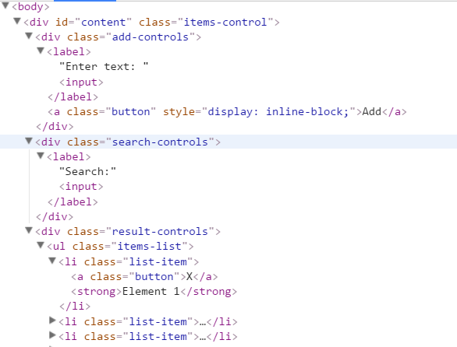

## *Calendar

Write a program that **generates** a monthly calendar by given date. It should be formatted as an **HTML table** with a **caption** for the month and year and headings for each column for the days of the week. The current date must be **highlighted** with a **different style** than the rest of the table cells.

### Screenshots

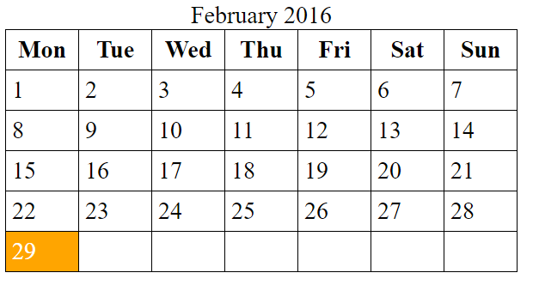

### HTML and JavaScript Code

You are given the following **HTML** code:

|  |
| --- |
| calendar.html |
| <!DOCTYPE **html**> <**html lang="en"**> <**head**>  <**meta charset="UTF-8"**>  <**title**>Calendar</**title**>  <**script src="https://code.jquery.com/jquery-3.1.0.min.js"  integrity="sha256-cCueBR6CsyA4/9szpPfrX3s49M9vUU5BgtiJj06wt/s="  crossorigin="anonymous"**></**script**>  <**style**>  **table**, **th**, **td** {  **border**: 1**px solid black**;  **padding**: 0.25**em**;  **margin**: 0;  **border-collapse**: **collapse**;  **border-spacing**: 0;  }  **th**, **td** {  **width**: 2.5**em**;  }  .**today** {  **background-color**: **orange**;  **color**: **white**;  }  </**style**> </**head**> <**body**> <**div id="content"**> </**div**> <**script src="calendar.js"**></**script**> <**script**>  **window**.onload = **function**(){  *calendar*([15,1,2017]);  } </**script**> </**body**> </**html**> |

It comes together with the following **JavaScript** code:

|  |
| --- |
| calendar.js |
| **function** *calendar*() {  *//* ***TODO*** } |

Your script needs to insert the generated calendar in the #content div. The resulting table should have the following format:

|  |
| --- |
| HTML |
| <**table**>  <**caption**>January 2017</**caption**> *<!-- Table caption -->* <**tbody**>  <**tr**>  <**th**>Mon</**th**> *<!-- Heading -->* …  </**tr**>  <**tr**>  <**td**></**td**> *<!-- Empty element -->* …  <**td**>1</**td**>  </**tr**>  <**tr**>  …  <**td class="today"**>15</**td**> *<!-- Current date is highlighted -->* </**tr**>  …  </**tbody**> </**table**> |

Your function will receive an array of three numbers representing a date as follows: [day, month, year]

### Requirements

* Current **month** and **year** are listed in a <caption> element with the month displayed as a **full capitalized name** and the **year** with **all digits**;
* The **first row** contains **headings** for the **days** **of the week**, **shortened** to **3 letters**: **Mon**, **Tue**, **Wed**, etc.;
* Each week is a complete row – **pad** the week with **empty cells** (empty string as cell content) if the month **doesn’t start on a Monday** or **end on a Sunday**;
* The table should contain **only as many rows as needed** – some months may need 6 weeks, others just 5.

### Hints

* JavaScript has a built-in Date object, which can be used to construct a date with arguments and then extract the current day of the week using the getDay() method. You can familiarize yourself with the object properties here: <http://www.w3schools.com/jsref/jsref_obj_date.asp>
* Try setting the day of the **month** to **0** and see what the result will be.
* Notice that the passed in arguments in the example **[15, 1, 2017]** correspond to **15th January 2017**

## **Wiki Parser

You are tasked by Wikipedia to write a JS program that parses text according to their internal markup in the browser. Your program will receive a **selector** to a **paragraph** of text and has to scan it for special symbol combinations that denote specific style for the text that is enclosed in them. For instance, text surrounded by double single quotes (''text'') must be displayed in italics. Look bellow for a full list of features.

### Screenshots

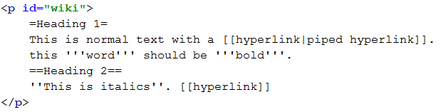

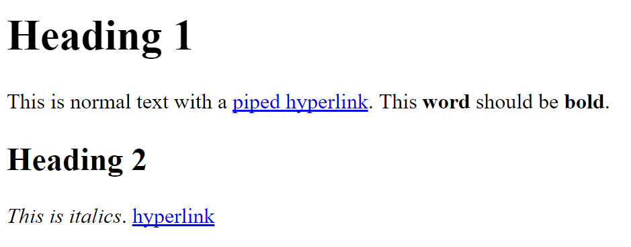





### HTML and JavaScript Code

You are given the following **HTML** code:

|  |
| --- |
| wiki-parser.html |
| <!DOCTYPE **html**> <**html lang="en"**> <**head**>  <**meta charset="UTF-8"**>  <**title**>Wiki Parser</**title**>  <**script src="https://code.jquery.com/jquery-3.1.0.min.js"  integrity="sha256-cCueBR6CsyA4/9szpPfrX3s49M9vUU5BgtiJj06wt/s="  crossorigin="anonymous"**></**script**> </**head**> <**body**> <**div**>  <**p id="wiki"**>  =Document title=  ==First segment==  '''bold 1''' word ''italics 1'' '''bold2'''  [[hyper first]] '''Bold three''' ''italics2'''  word [[hyper2]] [[hyperlink2|with Label]]  ==Second segment==  ===Third segment===  word '''word'''[[pipe|bomb]]  </**p**> </**div**> <**script src="wiki-parser.js"**></**script**> <**script**>  **window**.onload = **function**(){  *wikiParser*(**'#wiki'**);  } </**script**> </**body**> </**html**> |

It comes together with the following **JavaScript** code:

|  |
| --- |
| wiki-parser.js |
| **function** *wikiParser*() {  *//* ***TODO*** } |

Your function will receive a selector to an HTML element.

### Markup

The following symbols must be recognized and parsed:

* ''text'' becomes <i>text</i> (two single quotes)
* '''text''' becomes <b>text</b> (three single quotes)
* =text=, ==text== and ===text=== become <h1>text</h1>, <h2>text</h2> and <h3>text</h3>
* [[link]] becomes an anchor to /wiki/link with the same text, <a href="/wiki/link">link</a>
* [[link|Text]] becomes an anchor to /wiki/link with the argument after the pipe as text, <a href="/wiki/link">Text</a>

Note all resulting hyperlinks are relative to /wiki

### Constraints

* There will be no overlapping markup, i.e. there won’t be bold text inside a heading or a link
* All hyperlinks will only consist of valid characters